**WEEK 5:** **Pipeline Automation with Azure DevOps**

**Pre-requisites:**

* Ensure **SSH Public Key** or **Personal Access Token (PAT)** for HTTPS is already configured.
* Install **Git**, **Python**, and **VS Code / any IDE**.
* Have your project folder ready on your local system, which includes:
  + Python file for **expense alert**
  + Azure pipeline YAML file

**Step 1:**

1. **Create Python and YAML Files in Local Project**

## Create a Python file(report_generator.py)

import pandas as pd

# Load final student-course-progress data

df = pd.read_csv("final_Course _Output.csv")

# Filter students with progress < 50%

low_progress = df[df["progress"] < 50]

# Save the report

low_progress.to_csv("progress_report.csv", index=False)

print("progress_report.csv generated.")

1. **Create a YAML file for Azure Pipeline (e.g. azure-pipelines.yml)**

trigger:

schedule:

- cron: "0 8 * * 1" # Runs every Monday at 8 AM UTC

displayName: Weekly Monday Run

branches:

include:

- main

always: true

pool:

vmImage: 'ubuntu-latest'

steps:

- task: UsePythonVersion@0

inputs:

versionSpec: '3.10'

- script: |

pip install pandas

displayName: 'Install pandas'

- script: |

python check_progress.py

displayName: 'Run Weekly Progress Check'

- task: PublishBuildArtifacts@1

inputs:

PathtoPublish: 'progress_report.csv'

ArtifactName: 'WeeklyProgressReport'

publishLocation: 'Container'

displayName: 'Publish Weekly Progress Report'

**Step 2: Create a New Azure DevOps Project**

1. Go to [Azure DevOps Portal](https://dev.azure.com).
2. Click **New Project** → Provide name and visibility → Click **Create**.
3. Navigate to **Repos** → Click **Clone** → Copy the **SSH** URL.

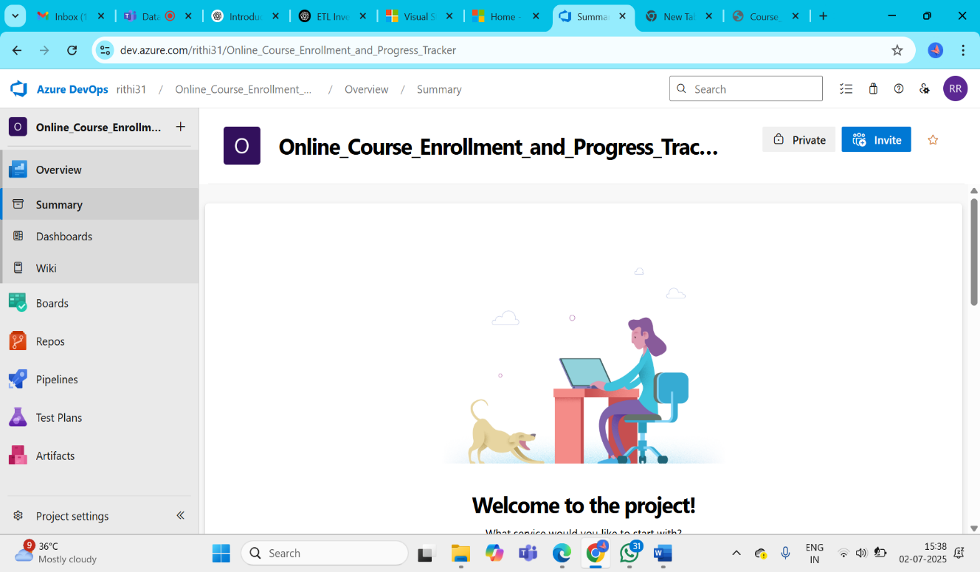

**Step 3: Push Local Project to Azure Repo via SSH**

Open **Command Prompt / Git Bash**, then run the following:

# Go to the directory where your local project exists

cd path\to\your\project-folder

# Initialize git repository

git init

# Add files to git

git add .

# Commit the files

git commit -m "Initial commit"

# Add Azure DevOps repo as remote (replace with your SSH link)

git remote add origin git@ssh.dev.azure.com:v3/YourOrg/YourProject/YourRepo

# Push the code to Azure repo

git push -u origin main

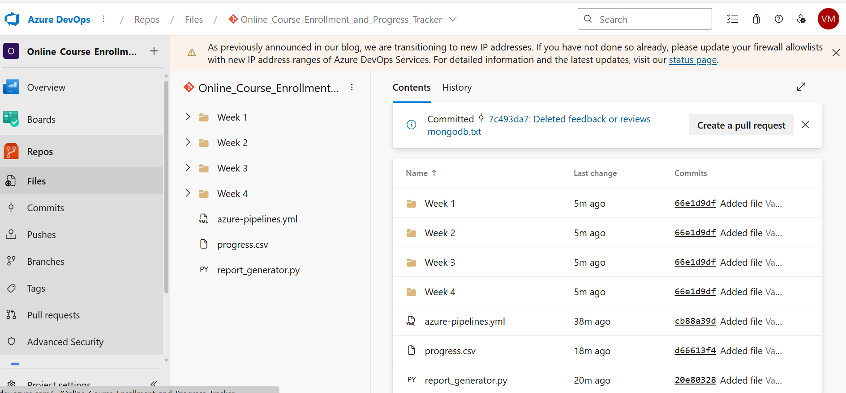

**Step 4: Configure and Run the Azure Pipeline**

1. Go back to your Azure DevOps project.
2. Navigate to **Pipelines** → Click **Create Pipeline**.
3. Choose:
   * **Code in Azure Repos Git**
   * Select your repository
   * Choose **"Existing Azure Pipelines YAML file"**
4. Select:
   * **Branch:** main
   * **Path:** /devops/azure-pipelines.yml
5. Click **Continue**, then **Run** the pipeline.

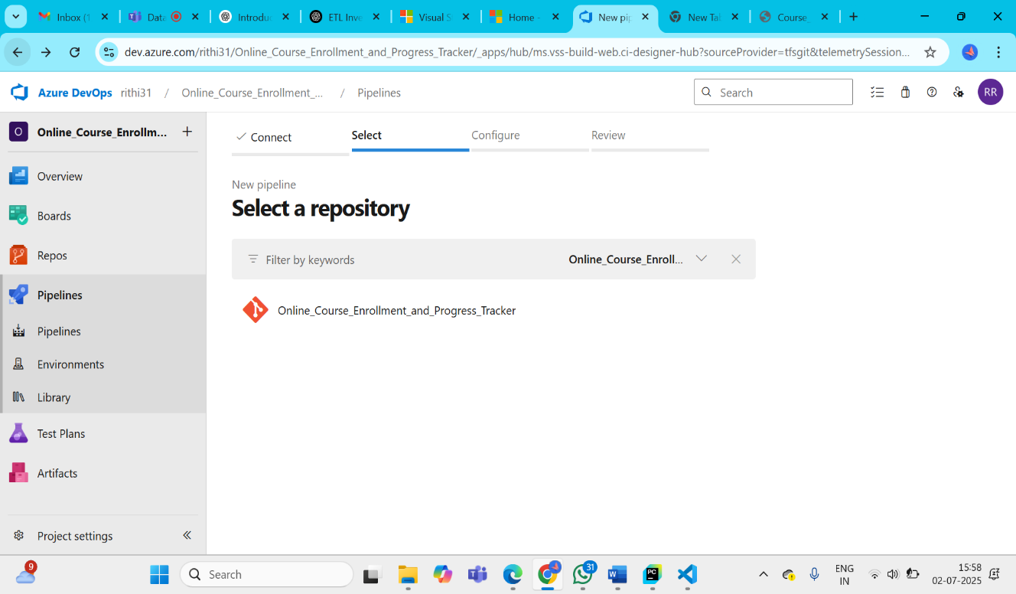

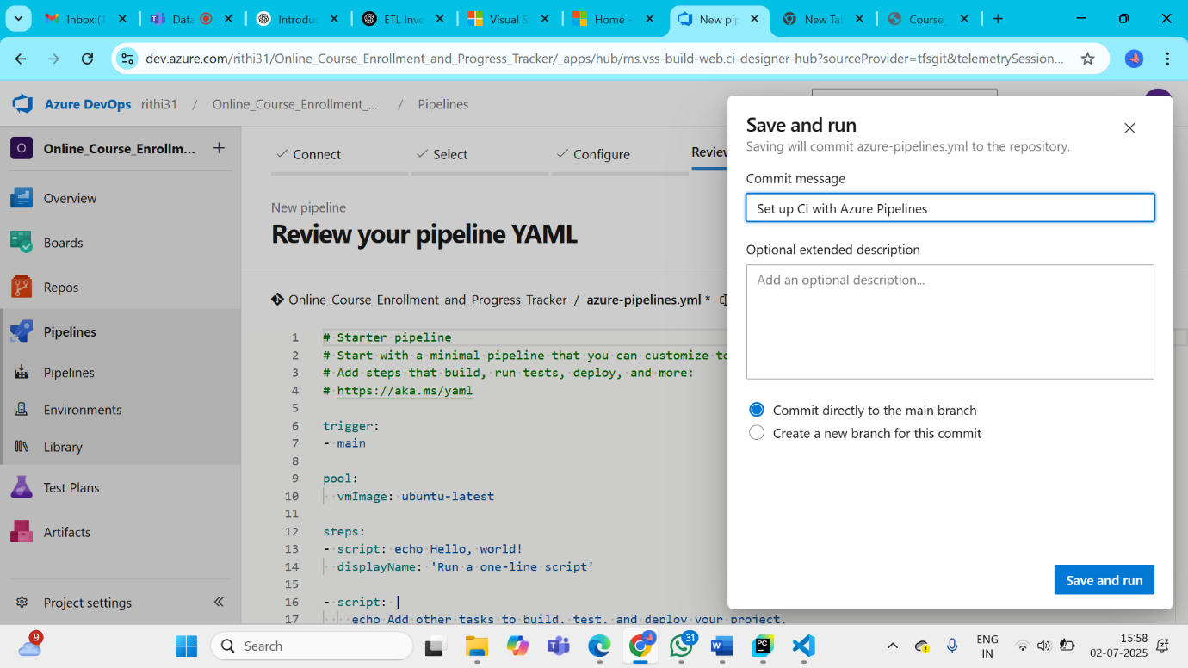

**STEP 5: Final Output**

- The pipeline will automatically run every Monday at 8 AM UTC.  
- It will generate `progress_report.csv` with students having less than 50% progress.  
- The CSV will be available as a build artifact in Azure DevOps.

